Index Number : 22424194
Course Code : ASTA 607
Course Name: Computational Statistics I

Question 1
- The crabs data frame has 200 rows and 8 columns, describing 5 morphological measurements on 50 crabs each of two colour forms and both sexes, of the species Leptograpsus variegatus collected at Fremantle, W. Australia.
The variables in the dataset are as follows
Sp: species - "B" or "O" for blue or orange.
Sex: Sex
Index: index 1:50 within each of the four groups.
FL: frontal lobe size (mm).
RW: rear width (mm).
CL: carapace length (mm).
CW: carapace width (mm).
BD: body depth (mm).

Source Campbell, N.A. and Mahon, R.J. (1974) A multivariate study of variation in two species of rock crab of genus Leptograpsus. Australian Journal of Zoology 22, 417–425.

- Data Sructure
crabs
str(crabs)

str(crabs)
'data.frame': 200 obs. of 8 variables:
$ sp : Factor w/ 2 levels "B","O": 1 1 1 1 1 1 1 1 1 1 ...
$ sex : Factor w/ 2 levels "F","M": 2 2 2 2 2 2 2 2 2 2 ...
$ index: int 1 2 3 4 5 6 7 8 9 10 ...
$ FL : num 8.1 8.8 9.2 9.6 9.8 10.8 11.1 11.6 11.8 11.8 ...
$ RW : num 6.7 7.7 7.8 7.9 8 9 9.9 9.1 9.6 10.5 ...
$ CL : num 16.1 18.1 19 20.1 20.3 23 23.8 24.5 24.2 25.2 ...
$ CW : num 19 20.8 22.4 23.1 23 26.5 27.1 28.4 27.8 29.3 ...
$ BD : num 7 7.4 7.7 8.2 8.2 9.8 9.8 10.4 9.7 10.3 ...

- Frequency Table for species and sex
freq_table<-table(crabs$sp,crabs$sex)
freq_table

F M
B 50 50
O 50 50

- Bar chart summarizing the group composition
barplot(freq_table,
main = "Group Composition",
xlab = "Sex",
ylab = "Frequency",
beside =T,
legend.text = T,
col = c("blue","orange"))

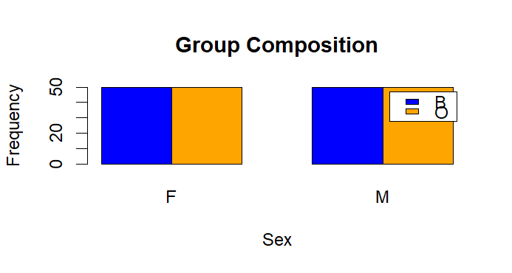

- There is equal number of blue and orange crabs across and within both sex and there is equal representation of both sex so the dataset is balanced.

Question 2
- Boxplots of BD for the four groups
boxplot(BD~interaction(crabs$sp, crabs$sex),
crabs,
main = "Combined group by Depth Body",
xlab = "Combined Species and Sex",
ylab = "Body Depth",
col = c("blue","pink",'lightblue',"orange")
)
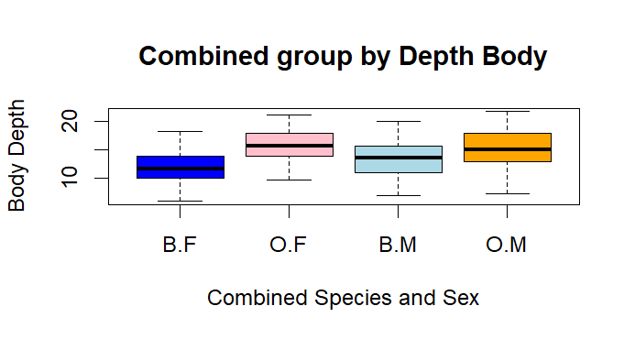
- Outliers: There don’t appear to be any outliers in any of the groups, as all values fall within the whiskers of the boxes.
Central tendency: Looking at the median lines, males generally have higher body depth than females within the same species. Also, species O crabs tend to have larger body depth than species B.
Variability: The spread of body depth, measured by the box height (IQR) and whiskers, is similar for all groups. The group O.M has the highest maximum value, while B.F has the lowest minimum, but overall the variation is comparable across the groups.
In conclusion, No outliers, males are larger than females, species O crabs are bigger than species B, and the spread of body depth looks the same for all groups.

Question 3
- Histograms of carapace length (CL) for each species
par(mfrow = c(1,2))
for (sp in levels(crabs$sp)){
x<-crabs$CL[crabs$sp == sp]
hist(x, main = paste("Carapace Length:",sp),
xlab = "Carapace Length"
)
}

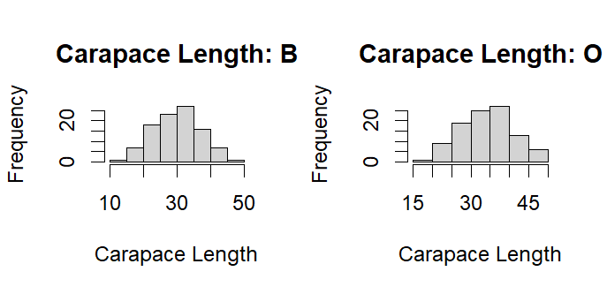
- Both species’ carapace lengths are almost symmetric showing a bell-shape. The carapace length of the blue species is not skewed while that of the orange species is slightly skewed to the left

Question 4
- Mean
Data.frame(numeric_cols <- sapply(crabs, is.numeric)
aggregate(crabs[, numeric_cols],
by=list(Species=crabs$sp,
Sex=crabs$sex), FUN=mean))

Species Sex index FL RW CL CW BD
1 B F 25.5 13.270 12.138 28.102 32.624 11.816
2 O F 25.5 17.594 14.836 34.618 39.036 15.632
3 B M 25.5 14.842 11.718 32.014 36.810 13.350
4 O M 25.5 16.626 12.262 33.688 37.188 15.324

Question 5
crab_measures <- crabs[, c("FL", "RW", "CL", "CW", "BD")]

pairs(crab_measures,
main = "Scatterplot Matrix of Crab Measurements",
pch = 19,
col = crabs$sp)

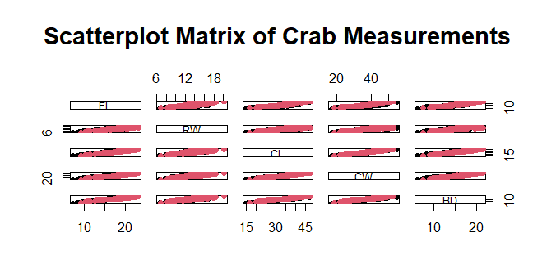

Question 6
The crabs dataset has 200 crabs with species, sex, and five body measurements. Body depth is mostly symmetric with a few larger crabs as outliers. Carapace length shows that orange crabs are generally bigger than blue ones, and males are slightly larger than females. Mean measurements confirm that orange crabs and males tend to be larger overall. All measurements are positively correlated, meaning bigger crabs in one trait are bigger in the others. Species and sex both clearly influence crab size, and the patterns are consistent across traits.

